**Project Plan**

| Driver | Abhijith Ezhuthachan |
| --- | --- |
| Approver | Aditya Kumar |
| Contributor | Abhijith Ezhuthachan |
| Objective | Implement GenAI Capabilities in OneCustomerView |
| Due Date | 19/07/23 |
| Key Outcomes | Exploration and Implementation of GenAI Capabilities in existing OneCustomerView demonstration. |
| Status | In Progress |

**Scope**

| Must have: | GenAI capabilities in the OneCustomerView demonstration that will enhance the value of existing system. Generate recommendation on customer segments on the click of a button stating what should be done for this segment and what should not be done for this segment. |
| --- | --- |
| Nice to have: | Intuitive User Interface on this feature with low latency |
| Not in scope: | Summarization of tables in existing demonstration. Summarization of images/charts in existing demonstration. |

**Experimentation**

After going through the existing demonstration in detail, ideas were suggested that included summarization of tables in the existing system, summarization of images/charts in the existing system and recommendation of what to be done/what not to be done on a particular segment. It was decided to focus more on the part where recommendation of what to be done/what not to be done on a particular segment would be given.

For the backend of Generative AI, an open source Large Language Model from OpenAI GPT3 released in 2020 was used. Installation of the above model was done using open source Python Library openai. A python script was written where the input to the model would be the table consisting of the following columns S.No, Next Best Product, Next Best Action, Customer Segment, Total Customers, Positive Causality, Negative Causality, Effect and Priority. Apart from these also tried out were tables with dummy data and Causality Factors of a Hospitality Dataset. Following are the detailed tables that were used for this purpose.

1. Dummy Data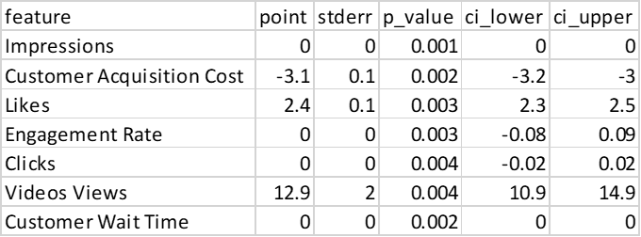

2. Causality Table

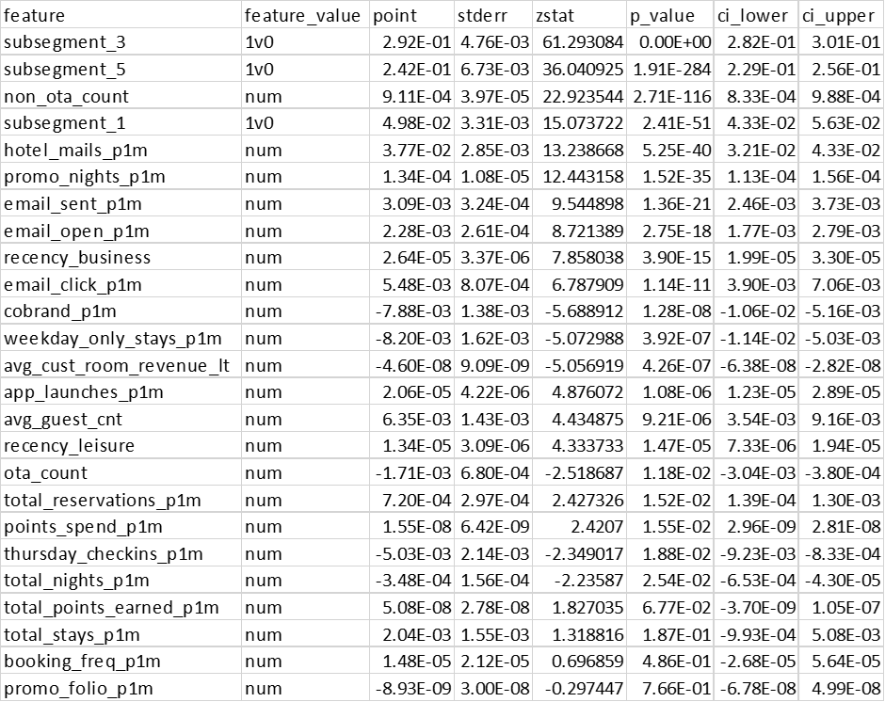

3. Sample data from demo

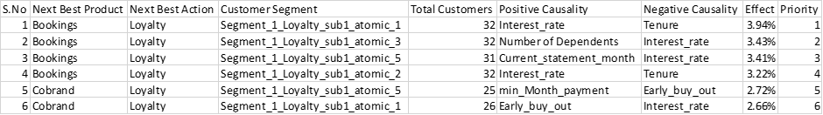

At the start more focus was given on working with the first two tables and code development so as to make it refined to the final output required. Later once the input was decided it was going to be of the 3rd table type, focus was given on getting the correct question or prompt to ask the LLM. Based on the input data, different prompts were tried out of the following sort.

* Positive Response
* Summarise this table.
* Tell most and least significant feature in this table.
* Tell the top 2 most and least significant features in this table.
* What should be done and should not be done from this table.
* What should be done and should not be done for this data.
* For this customer segment, what is the next best product, next best action, positive causality and negative causality.

* Negative Response
* Frame the positive causality as a sentence that should be done and negative causality as a sentence that should not be done.
* From a marketing perspective, what is the best thing that can be done for this data?
* Think of yourself as a marketing expert. Based on this data what is the next best product, next best action, positive causality and negative causality?

The outputs from prompts in the positive response were of the acceptable level and outputs from prompts in the negative response were not upto the mark. As the output from the LLM is going to vary everytime, judging the correctness of response lies purely on the observer. Some of the outputs received from different prompting exercise include,

* From this data, it should be done to focus on the loyalty sub-segment of Segment_1 and offer them an incentive based on the interest rate to increase their bookings. It should also be done to reduce the tenure of the customers to further increase their bookings.

It should not be done to focus on any other customer segment or action besides loyalty and bookings. It should also not be done to ignore the priority of 1 given to this data.

* What should be done:

1. Analyze the data to identify correlations between customer segment, positive causality, negative causality, and effect.

2. Use the data to create a strategy for the next best product and next best action to promote loyalty for the customer segment.

3. Assess the priority of the data to determine the best course of action.

* What should not be done:

1. Do not ignore the data or make assumptions without analyzing it.

2. Do not make decisions without considering the effect of the data on customer loyalty.

3. Do not overlook the importance of the priority of the data.

* Positive Causality: Increase the interest rate to encourage customers to make bookings and loyalty programs.

Negative Causality: Do not increase the tenure to encourage customers to make bookings and loyalty programs.

* The next best product for this customer segment is bookings, which will enable them to take advantage of loyalty rewards and discounts. The next best action for this customer segment is to engage in loyalty programs. The positive causality for this segment is interest rate, which can be used to incentivize them to stay loyal to the business. The negative causality is tenure, which can be used to identify customers who have been loyal for a long period of time. The effect of these actions is a 3.94% increase in customer loyalty. The priority for this customer segment should be to focus on loyalty programs and bookings.
* The best thing that can be done from a marketing perspective is to create a loyalty program tailored to the Segment_1_Loyalty_sub1_atomic_1 customer segment. This program should incentivize customers to book more products and services with the company in order to increase their loyalty and spend. Rewards such as discounts, free products, or other promotional items should be offered to customers who meet certain criteria, such as the amount of time they have been a customer or the number of purchases they have made. Additionally, the company should focus on increasing the interest rate and decreasing the tenure to further increase the effect of 3.94%. Finally, this should be a priority as it can help to increase customer loyalty, customer satisfaction, and ROI.
* Next Best Product: Rewards Program

Next Best Action: Increase loyalty by offering incentives and rewards to customers

Positive Causality: Increase in customer engagement

Negative Causality: Increased customer attrition

Effect: Increased customer satisfaction and loyalty

Priority: High

Possible solutions explored to improve output

**Fine-tuning**

Developers can now fine-tune GPT-3 on their own data, creating a custom version tailored to their application. Customizing makes GPT-3 reliable for a wider variety of use cases and makes running the model cheaper and faster.

Fine-tuning lets you get more out of the models available through the API by providing:

1. Higher quality results than prompt design
2. Ability to train on more examples than can fit in a prompt
3. Token savings due to shorter prompts
4. Lower latency requests

Hurdles:

Data Sharing Issues that may arise from sharing data with OpenAI.

**BERT**

BERT is an open source machine learning framework for natural language processing (NLP). On testing BERT out on the same data, all it did was return the data in a different format whereas for the complete tabular data no output was received.

**Outcome**

As of now we have a python script that is capable of generating relevant text pertaining to a table that is provided. Next steps would be to figure out improving accuracy of responses generated, trying out different LLMs and integrating it into the existing demonstration.